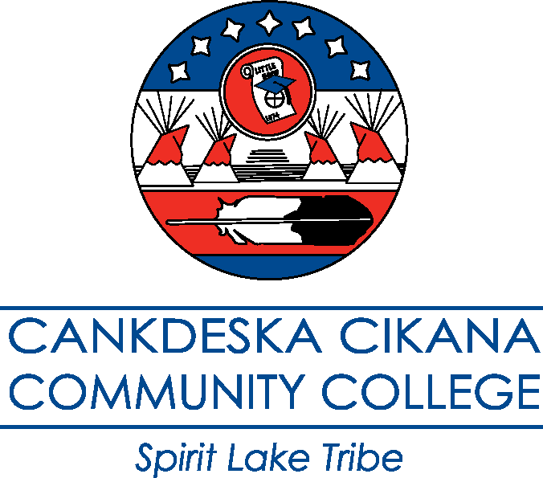

Policy on Academic Programs and Courses
Approved by the Board of Regents 8/7/19

Academic Governance

The Cankdeska Cikana Community College (CCCC) Curriculum Committee, in consultation with the Academic Dean and Registrar, is the governing body for oversight of the CCCC program review process together with oversight of all academic programs, courses, and programs of study. The Curriculum Committee consists of at least three (3) voting full-time faculty members, with the Academic Dean, Dean of Student Services, and Registrar serving as non-voting members. The committee ensures the academic integrity and educational excellence of CCCC through the following activities:

Recommend all credit and non-credit courses for approval to the Academic Dean

Recommend course changes, additions, deletions and program changes or furloughs for approval to the Academic Dean

Review of new proposed programs according to the Program Review Guide, forwarding recommendations to program faculty, the Academic Dean, President and Board of Regents

Periodic review of existing programs according to the Program Review Guide, forwarding recommendations to program faculty, the Academic Dean, President and Board of Regents (Board approval needed only for furloughs of existing programs)

Regular review of Essential Studies (General Education) requirements and graduation requirements for all CCCC AA, AS, AAS, and certificate programs, forwarding appropriate recommendations to the Academic Dean and President and ensuring program of study compliance with requirements

Regular review of college policies affecting course integrity, such as add/drop and credit by examination

Regular review of the North Dakota University System’s current General Education Requirements Transfer Agreement (GERTA), forwarding recommendations to the Academic Dean and Registrar

Providing notice to faculty and appropriate stakeholders regarding the decisions of the Committee

Items for Submission to the Curriculum Committee

Requests for new courses or deletion of courses (credit and non-credit)

Requests for new programs, program changes, or furlough of programs

Revisions to courses including:

Course number or title

Credits

Course catalog description

Pre-requisites or co-requisites

Content-extensive changes to topics

Changes in sequence or semester rotation of courses

Courses to be reinstated

Other concerns including Essential Studies courses, changes in entrance requirements for matriculation or admission to specific degree programs, or any change affecting the educational objectives of a program or the college

Note: All course changes must meet the requirements for academic rigor and the CCCC Credit Hour Policy requirements.

Approved Processes

Adding a Program of Study

Occurs on an as-needed basis

- Staff requesting a new program must submit a Program or Course Change of Request Form (see Appendix A) to the Academic Dean, Program Review Administrator, and Curriculum Chair, along with a Program Review document (using the approved CCCC Request for New Program Template) and a copy of the proposed program of study including course rotation.

- The Curriculum Committee will meet to review the documents and will take into consideration the following:
  - Are the Essential Studies requirements of CCCC met?
  - Are the credit hours appropriate? (for example, at least 60 credit hours for an AS, AAS, or AA degree; at least 16 credit hours for a Certificate)
  - Is it viable? (faculty, resources, prospective students)
  - Is it going to be transferable?
  - Does it meet the North Dakota University System degree requirements?

- If the program is not approved, the Curriculum Committee Chair will forward reasons for denial and any recommended revisions back to the staff. The staff proposing the program will have the option of making revisions and returning it to the Committee for reconsideration.

- Once a new program is approved by the Curriculum Committee, the program review document and the new program of study will be signed by the Chair and the Program Review Administrator and sent to the Academic Dean for approval.

- If approved, the Academic Dean will sign and forward the program review document and the program of study to the Dean of Administration for approval.

- If approved, the Dean of Administration will sign and forward the program review document and the program of study to the President for approval.

- The President will review the recommendation; if approved, the President will sign and forward the recommendation to the Board of Regents for final approval and signature, returning the final signed document to the Program Review Administrator.

- Board action will be conveyed by the Program Review Administrator to the requesting staff, Academic Dean, Dean of Administration, Dean of Student Services, Curriculum Committee, Student Advisors and Mentors, Registrar, Admissions, Business Office, website/catalog administrator, and Financial Aid Director.

Furloughing a Program

Occurs on an as-needed basis

- Program furloughs can be requested by submitting a Program or Course Change of Request Form (see Appendix A) along with a final Program Review document (using the approved CCCC Program Review Template) to the Academic Dean, Program Review Administrator, and Curriculum Chair. In accordance with the CCCC Program Review Guide, if the Curriculum Committee receives a furlough request or determines during the program review process that a program should be furloughed, the committee will assist program faculty in drafting a final Program Review document detailing concerns, along with their recommendation, will be signed by the Chair and the Program Review Administrator and forwarded to the Academic Dean.

- If the Academic Dean agrees with recommendation for furlough, the document will be signed and forwarded the to the Dean of Administration.

- If the Dean of Administration agrees with recommendation for furlough, the document will be signed and forwarded to the President.

- If the President agrees with recommendation for furlough, the document will be signed and presented to the Board of Regents for consideration.

- The Board of Regents will act on the recommendation, with the President returning the signed review document to the Program Review Administrator.

- Board action will be conveyed by the Program Review Administrator to the Academic Dean, Dean of Administration, Dean of Student Services, the Curriculum Committee, Program Faculty, Student Advisors and Mentors, Registrar, Admissions, Business Office, website/catalog administrator, and Financial Aid Director.

- The Registrar will convey information regarding the furlough of a program of study to all student advisors and will provide students currently enrolled in the program of study with a plan for completion/graduation.

Adding a New Course

Occurs on an as-needed basis for ALL courses including, but not limited to, Continuing Education Units (CEU’s), Essential Studies courses, Distance Education courses, and Community Service courses

- Staff requesting a new course must submit a Program or Course Change Request Form (see Appendix A) along with a proposed copy of the course syllabus (using the approved Syllabus Template) to the Academic Dean and Curriculum Chair.

- The Curriculum Committee will meet to review the request.

- If revisions are needed, the Curriculum Committee will forward the recommended revisions back to the Staff requesting the new course. The Staff requesting the new course will make the revisions and return it to the committee for approval.

- If the course is not approved, the Curriculum Chair will notify (citing the reasons) the President, Academic Dean, and Staff requesting the new course.

- If the course addition is approved, the Curriculum Chair will notify the Staff requesting the new course.

- Once approved, the Curriculum Chair will forward a copy of the course syllabus to the Registrar, Admissions, and website/catalog administrator.

Deleting a Course

Occurs on an as-needed basis for ALL courses including, but not limited to, Continuing Education Units (CEU’s), Essential Studies courses, Distance Education courses, and Community Service courses

- If courses are in the college catalog that are not being offered or are not part of a program of study, the Curriculum Committee may recommend removing the courses from the catalog or deleting the course. The Academic Dean may also recommend to the Curriculum Committee that a course, or courses, be removed from the catalog or deleted.

- The Curriculum Committee will discuss all courses in question. The discussion will focus on enrollment, how often it is taught, whether it can be used as a Liberal Arts elective, or other concerns.

- The Curriculum Committee will forward recommendations to the Academic Dean for approval.

- Once approved by the Academic Dean, a list of the deleted courses will be forwarded to the President, the Curriculum Committee, Student Advisors and Mentors, Registrar, Admissions, website/catalog administrator, and Financial Aid Director.

Requests for Course Changes

Occurs on an as-needed basis for ALL courses including, but not limited to, Continuing Education Units (CEU’s), Essential Studies courses, Distance Education courses, and Community Service courses

- All course change requests shall be submitted using the Program or Course Change Request Form (see Appendix A) along with a proposed syllabus (using the approved Syllabus Template) to the Curriculum Chair and Academic Dean. (See Items for Submission to the Curriculum Committee on page 2 of this document).

- The Curriculum Committee, Academic Dean, and Registrar will review the requested changes to ensure all changes meet all institutional criteria and program alignment.

- Notification of decision will be forwarded by the Curriculum Chair to the faculty proposing the course change, program faculty, admissions, and the Registrar. Any change in GERTA approved courses will be submitted by the Registrar to the NDUS for approval.

Appendix A – Program or Course Change Request Form


Program or Course Change Request Form

Date: _____________________ Requestor: ________________________

Program:______________________________________________________________________

Type of Request (check all that apply):
Program/Program of Study Change Request
New program request (attach program review document)
Program furlough request (attach program furlough document)
Change in program outcomes (attach current and proposed program outcomes)
Program of Study revision (attach current and proposed program of study with course rotation)

Course Change Request
*Note: All course change requests must be accompanied by syllabi reflecting proposed changes.
GERTA or CCN request to NDUS
Course numbering or title change
Course description, pre-requisites,
or sequence change
Course credit change
Content-extensive change in topics
or course outcomes
Course deletion
New course addition

Briefly describe the change(s) being requested. Include reason for change.

*Submit all requests to the Academic Dean and Curriculum Committee Chair.

Committee Use Only

Request reviewed by Committee
Approved/Date: ___________________ Effective Date: _____________________
Denied/Reason:

Results communicated to Requestor.

Changes forwarded for posting on website (if applicable)

Notification of Stakeholders:
Academic Dean (all program and course changes)
Registrar (all program and course changes)
Admissions (all program and course changes)
Advisors/mentors (all program and course changes)
Dean of Administration (program changes only)
Dean of Student Services (program changes only)
Financial Aid Director (program changes only)
Business Office (program changes only)
President (program changes only)

