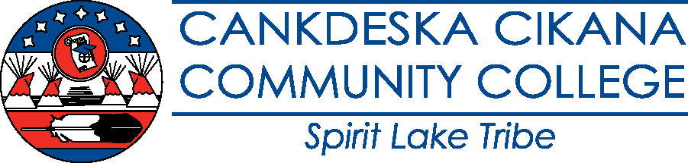

CCCC 3-Year Program Review Schedule 2026 – 2029

2026 – 2027:
AS Natural Resource Management
AA Liberal Arts
AA Business Administration (AA and Certificate Administrative Assistant)

2027 – 2028:
AA Early Childhood Education
AS Pre-Engineering
AA Fine Arts

2028 – 2029:
AA Indigenous Studies (AA and Dakota Language Certificate)
AA Social Work
Professional Driving (CDL) Certificate
Carpentry Certificate

Program Reviews are due to the Academic Dean, Program Review Administrator, and Curriculum Committee Chair by October 1st of the designated year. All programs will complete and submit the program review using the prefilled CCCC Program Review Template provided by the Program Review Administrator and following the CCCC Program Review Process.

Spring Program Snapshots using the prefilled CCCC Program Snapshot Template provided by the Program Review Administrator are required annually for all programs. Program Snapshots are due to the Academic Dean, Program Review Administrator, and Curriculum Committee Chair by March 31st each year.

Fall Reporting on the Status of Program Goals using the prefilled Program Goal template provided by the Program Review Administrator is required annually for all programs. Status reports are due to the Academic Dean, Program Review Administrator, and Curriculum Committee Chair by September 15th each year.

