PROGRAM REVIEW GUIDE


Table of Contents
Program Review Responsibilities, Roles, and Objectives Page 3
Program Review Process Linkages and Integration Page 3
Program Review Process Summary Page 4
Program Review Process Flowchart Page 6
Current 3-Year Schedule for Program Review Page 7
Program Review Template Page 8
Program Snapshot Template Page 23
Program Goal Status Template Page 25
Program Review Exit Meeting Template Page 26

Program Review
Faculty, staff, and administration are required to participate in the program review process as a means to review and strengthen CCCC programs of study to better serve students. Program review also provides a means for examining new programs for possible adoption or furloughing/discontinuing programs. The Program Review Guide is located on the CCCC website. The Academic Dean, Program Review Administrator, and Curriculum Committee provide oversight of, and assistance to, faculty completing the program review process.

CCCC Program Review Objectives ___________
Primary: Documented, periodic self-study of each program’s performance
- Demonstrate areas of satisfactory performance
- Identify areas in need of development or revision
- Maintain and improve the quality and scope of instruction and service
Secondary: Program Planning
- Development of a program plan to include short-term and long-term goals
- Evaluation of potential programs
- Furlough of existing programs as necessary

Program Review provides linkage and integration with the following processes:
- Accreditation: The Program Review process addresses requirements included in the Higher Learning Commission standards for the systematic evaluation by the institution relating to its Strategic Plan, educational planning, assessment analysis, and budget development
- Institutional Research: Program Review is supported by institutional data and research, integrating planning and evaluation aligned with the Strategic Plan


Program Review Process Summary:
CCCC Program Review process consists of 3 components: Full Program Review is completed by program faculty every 3 years (October, November) according to the CCCC 3-year Program Review schedule; Program Snapshots are completed annually in the spring for every program; programs establish and/or revise annual program goals and report on Program Goal Status each fall. In-service on program review is conducted by the Program Review Administrator twice per year at the fall and spring faculty in-services and at designated all-staff meetings and Board meetings upon request.

Full 3-Year Program Review:
- A Program Review Template prefilled with program-specific data and detailing the required information is provided by the Program Review Administrator to the program faculty writing the review. The program faculty are assigned a member of the Curriculum Committee to act as a program review mentor to assist with writing and editing. Faculty work with their mentor in editing the template to create a Program Review document for their program. An example of a program review template is also provided in the Program Review Guide available on the website. This information is available to all program faculty at any time.
- Upon faculty completion of the Program Review document the document is to be reviewed and evaluated by the assigned mentor and Academic Dean. Program faculty review the feedback and make any needed edits. The program review document may need review a second time by the mentor and/or the Academic Dean, or many subsequent times, as deemed necessary prior to submission.
- After completing recommended edits, program faculty submit the Program Review to the Academic Dean, Curriculum Chair, and Program Review Administrator. Incomplete reviews or submitted documents needing further edits will be sent back to program faculty and/or their mentor for corrections; the document will need to be resubmitted after corrections are complete.
- Upon receipt of the review document, the Curriculum Committee conducts the formal review meeting, led by the Program Review Administrator. Program faculty are required to attend the meeting to present their review. The Curriculum Committee and Academic Dean evaluate the program utilizing a rubric to assess the strengths and weaknesses of the program. Recommendations are discussed and recorded into the review document.
- The final Program Review document is finalized and forwarded by the Program Review Administrator to the Academic Dean, Dean of Student Services, Dean of Administration, and President for signature/approval, forwarding the document to the Board as needed when major program changes occur (such as furlough recommendation or new program approval).
- Following the necessary signature approvals, the President returns the signed original document to the Program Review Administrator for filing. The approved document along with the results of the program review are disseminated to program faculty and all stakeholders at a Program Review Exit Meeting with budgeting needs determined, recorded, and communicated where applicable.
- The Program Review Administrator updates the CCCC Annual Program Review Summary Document with program review findings and program goals for the up-coming academic year; all program review documentation is posted to the website and disseminated across the institution.
New Program Request:
Requests for new programs must be vetted through the Academic Dean, Dean of Administration, and President to obtain permission to make the request. The Program Review Administrator will provide a New Program Template to be completed and submitted for review by the Curriculum Committee following the process for a full review (steps 2 – 7).

Request for Program Furlough:
Requests for program furlough must be vetted through the Academic Dean if initiated by program faculty, or initiated by the Academic Dean as requested by the President or as furlough need is demonstrated. The Program Review Administrator will provide a Program Furlough Template to be completed and submitted for review by the Curriculum Committee following the process for a full review (steps 2 – 7).

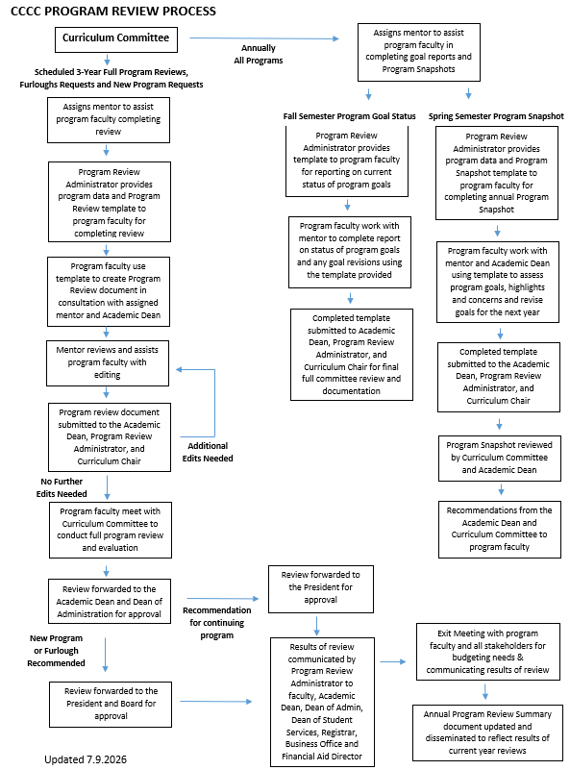


CCCC 3-Year Program Review Schedule 2026 – 2029

2026 – 2027:
AS Natural Resource Management
AA Liberal Arts
AA Business Administration (AA and Certificate Administrative Assistant)

2027 – 2028:
AA Early Childhood Education
AS Pre-Engineering
AA Fine Arts

2028 – 2029:
AA Indigenous Studies (AA and Dakota Language Certificate)
AA Social Work
Professional Driving (CDL) Certificate
Carpentry Certificate

Program Reviews are due to the Academic Dean, Program Review Administrator, and Curriculum Committee Chair by October 1st of the designated year. All programs will complete and submit the program review using the prefilled CCCC Program Review Template provided by the Program Review Administrator and following the CCCC Program Review Process.

Spring Program Snapshots using the prefilled CCCC Program Snapshot Template provided by the Program Review Administrator are required annually for all programs. Program Snapshots are due to the Academic Dean, Program Review Administrator, and Curriculum Committee Chair by March 31st each year.

Fall Reporting on the Status of Program Goals using the prefilled Program Goal template provided by the Program Review Administrator is required annually for all programs. Status reports are due to the Academic Dean, Program Review Administrator, and Curriculum Committee Chair by September 15th each year.

Program faculty in programs scheduled for full review will receive a prefilled template from the Program Review Administrator for use in preparing their program review document for submission.
Program Review Template

(NAME OF PROGRAM) PROGRAM REVIEW

I. Program description and relationship to the Cankdeska Cikana Community College mission. (See also Appendix A)
  - Describe the program of study and the role of the program within Cankdeska Cikana Community College.
    - Include a description of the program’s function that relates to the CCCC mission and the achievement of student outcomes.
    - Describe how the program is important to the various aspects of the mission: general education, transfer, career and technical training, workforce training, developmental education, educational outreach opportunities, life-long learning.

Brief Narrative (1 – 3 paragraphs)
Click or tap here to enter text.

Reflection
Strengths
Click or tap here to enter text.

Concerns
Click or tap here to enter text.

Concerns from last previous program review (give date of last review)
Click or tap here to enter text.

Progress on concerns from last previous program review
Click or tap here to enter text.

Recommendations (Curriculum Committee Use Only)

II. Program background information, enrollment and breadth (See also Appendix B)

  - Discuss the current number of program faculty and staff for and describe any changes in staffing that have occurred in the past 5 years.
  - Describe the courses offered and related faculty credit hour loads.
  - Discuss the total program student enrollment per semester over the past 5 years.
  - Discuss the total program graduates (degree, certificate) per year over the past 5 years.
  - Describe the ratio of graduates to majors over the past 5 years.
  - If the program has an advisory board, describe its role and list the members of the advisory board. Discuss any highlights of the advisory board meetings during the past two years.
  - Describe how the program provides graduates with necessary preparation for the workplace, success at a four-year institution, or actual entry-level certification.

Brief Narrative (1 – 3 paragraphs)
Click or tap here to enter text.

Reflection
Strengths
Click or tap here to enter text.

Concerns
Click or tap here to enter text.

Concerns from last previous program review (give date of last review)
Click or tap here to enter text.

Progress on concerns from last previous program review
Click or tap here to enter text.

Recommendations (Curriculum Committee Use Only)

III. Program Quality and Assessment (See also attached assessment template(s) Appendix C)
  - Describe how the program employs methods and systems of instructional delivery that are appropriate to the discipline and to the educational needs of students.
  - Describe the evidence that the program’s courses and programs successfully meet the learning and/or employment needs of students.
  - Describe how the program systematically collects and reviews student learning outcome data for courses and programs, takes active steps to improve achievement, and reports the results to the Assessment Committee.
  - Describe program assessment data that has been collected and analyzed for the last two assessment cycles and resulting actions.

Brief Narrative (1 – 3 paragraphs)
Click or tap here to enter text.

Reflection
Strengths
Click or tap here to enter text.

Concerns
Click or tap here to enter text.

Concerns from last previous program review (give date of last review)
Click or tap here to enter text.

Progress on concerns from last previous program review
Click or tap here to enter text.

Recommendations (Curriculum Committee Use Only)

IV. Program cost effectiveness and ability to meet occupational needs (See also Appendix D)
  - Discuss data to support evidence that program-related occupational opportunities are available in the tribal community, region, and state. Include national trend data from Indian Employment and Training (U.S. Department of Labor).
  - Describe program revenue and cost relationships for the past 5 years (or where data is available)
    - Include a summary of current program revenue sources and amounts, describing any changes to revenue sources over the past 5 years
    - Give a summary of program costs and annual expenditures over the past 5 years

Brief Narrative (1 – 3 paragraphs)
Click or tap here to enter text.

Reflection
Strengths
Click or tap here to enter text.

Concerns
Click or tap here to enter text.

Concerns from last previous program review (give date of last review)
Click or tap here to enter text.

Progress on concerns from last previous program review
Click or tap here to enter text.

Recommendations (Curriculum Committee Use Only)

V. Ability to positively impact CCCC’s relationships, partnerships, and alliances
  - Discuss whether the program possess adequate facilities, equipment, and technology to maintain the effectiveness of its courses and programs (if not, explain).
  - Discuss whether the institution provide adequate student services (library services and collections, tutoring, writing lab, counseling, etc.) to maintain the effectiveness of the program's courses and programs. Please explain.
  - Discuss whether the institution supports professional development activities that are adequate for faculty members to maintain and upgrade their knowledge and skills in the discipline. Please explain.
  - Describe the program’s contribution to other CCCC programs through its significant involvement in the general education program, its support to other college programs through service course offerings, or in other ways.

Brief Narrative (1 – 3 paragraphs)
Click or tap here to enter text.

Reflection
Strengths
Click or tap here to enter text.

Concerns
Click or tap here to enter text.

Concerns from last previous program review (give date of last review)
Click or tap here to enter text.

Progress on concerns from last previous program review
Click or tap here to enter text.

Recommendations (Curriculum Committee Use Only)

VI. Program Analysis and Reflection Narrative
  - Describe how the curriculum and course content, design, and delivery are reviewed regularly by the program and its advisory team, and when all course syllabi have been updated (at least once since the last program review).

  - Describe any particularly successful aspects of the program as well as any honors, awards, or achievements earned by the program and/or its members.

  - Describe any particularly difficult obstacles, either internal or external to the institution, which influence the effectiveness of the program's courses and programs (include response to problems identified in previous program reviews or other relevant assessments, internal or external).

  - Identify and describe any important trends in the following areas which have an effect on program goals (see below):

    - Changes within the discipline of the program.
    - Changes within the student population served by the program.
    - Changes within the educational, social, or economic sector served by the program.
    - Changes within the organizational structure and direction of the institution.
    - Changes within tribal colleges.
    - Changes in federal or state laws that have an effect on program functions.

  - Describe any new and revised goals and objectives for program improvement that were identified through the Program Review. Include both short-term (1 year) and long-term (5 years) objectives.

  - Identify additional resources needed to maintain and improve program quality and to reach the goals and objectives (for example: hours for part-time employees, cost of remodeling, adjunct faculty hours, software, equipment, faculty development, etc.

Narrative:
Click or tap here to enter text.

Appendix A
(Current CCCC Program of Study showing courses offered and suggested course rotation)
(will come prefilled by program)
Sample
Appendix B – Program Background Information, Enrollment, and Breadth

Faculty Program Staff and Credit Hour Loads (faculty fill in current program staff information)

Name | Title/Position | FT/PT/ TEMP | Credit Load/Semester

Enrollment and Graduation Data (5-year tables will come prefilled by program)

Sample

Appendix C – Program Quality and Assessment
(most recent two cycles of course/program assessment using current assessment template; this will come prefilled by program)

Assessment Plan
(Year) / (Semester)
(Program)

Program Statement:

Course Outcomes
(You need one of these for EVERY core course taught during that particular semester)
(Copy/paste from your syllabus)
Assessment Template

Program Outcomes
(Use your NEWLY REVISED program outcomes based on the 4 essential study outcomes)

Essential Studies Outcomes
1. Critical Thinking
2. Communication
3. Technological Literacy
4. Personal Attributes

- Area of Concern
Recommendation of assessment committee and/or faculty
Result of
Recommendation
- Area of Concern
Recommendation of assessment committee and/or faculty
Result of
Recommendation
- Area of Concern
Recommendation of assessment committee and/or faculty
Result of
Recommendation

- Area of Concern | Students were having difficulty recalling prior knowledge that was needed to progress into higher level sequential classes.
Recommendation of assessment committee and/or faculty | Find a way to incorporate common concepts throughout the curriculum to help reinforce prior knowledge learned.
Result of  Recommendation | Implemented embedded questions of common concepts throughout the curriculum coursework needed to progress to continually reinforce prior knowledge.
EXAMPLE

D-Direct I-Indirect  List activity(ies) used to measure student success | Goal | Findings - Results  (Refer to LEGEND) | Analysis  (Contributing factors  - Internal and External -resulting in not meeting goal) | Recommendations | Identify Course Outcome(s)  being demonstrated | Identify Program Outcome(s)  being demonstrated | Identify Essential Studies Outcome(s) being demonstrated
D –  I – | > | N =  NP =  SR =  Avg. =  Range =

Appendix D – Cost Effectiveness and Ability to Meet Occupational Needs

Occupational Needs
(Faculty to complete data in table from national trend data; cite all source(s) using APA Format)

National Employment Projections, 2020-2030
Bureau of Labor Statistics
Occupational Category |  | Projected Increase
Sample: Biological Science Teachers (Postsecondary) |  | 16.2%
Other Applicable Labor Projection Data
Occupational Category | Projected Increase
Source: list source webpage(s) here

Annual Revenue and Expenditures (5-year tables will come prefilled by program)

Sample

Other Program Revenue Sources and Expenditures:
(Give a detailed description of any additional program revenue sources, amounts, and frequency/ timeframes for receipt of the revenues; describe additional program-specific expenditures paid for through the additional revenue sources)

Program Evaluation and Review (for Curriculum Committee Use Only)

Criteria | Program Exceeds Expectations | Program Meets Expectations | Program Needs Improvement | Program Does Not Meet Expectations
Sec II Enrollment | Increasing | Steady | Decreasing | Unsustainably Low
Sec III Quality of the Program as Determined from Assessment Information | The program’s quality is substantial and notable. | The program’s quality is substantial but could be strengthened through curricular and/or program enhancements, e.g. providing additional resources, adding or deleting courses | The program’s quality could be strengthened through reconfiguration, e.g. substantial modification of the curriculum and the reorganization of faculty. | The program’s quality and/or contribution to the institution is not substantial enough to justify its continuance
Sec IV Cost Effectiveness | Net Gain | Break Even | Net Loss | Unsustainable Losses
Sec IV Projected Occupational Need (Regional and State Level) | Large Need and Growth in This Area | Moderate Need | Minor or Low Need | No Clear Need for This Degree
Sec V Ability to positively impact CCCC’s relationships, partnerships & alliances | Relationships are strong – benefits the overall mission of the college | Relationships, partnerships, and/or alliances could be developed to strengthen the program | Relationships, partnerships, and/or alliances need to be reconfigured in order to positively impact the college | Relationships, partnerships, and/or alliances are not positively impacting the college. The program’s reduction or phase out would not adversely impact other programs.

The Curriculum Committee makes the following recommendation(s):

Follow up actions and timeline:

Completed Program Review Verification

Name of Program Reviewed:

Director or Faculty of Record Date of Review

Curriculum Committee Chair Date of Review

Program Review Administrator Date of Review

Dean of Student Services Date of Review

Dean of Administration Date of Review

Academic Dean Date of Review

President (as appropriate) Date of Review


Chair CCCC Board of Regents (as appropriate) Date of Review

Program Snapshot Template

Spring (YEAR) Annual Program Snapshot
Program Name: Program Faculty:
(Ex: AA Business Administration) (Ex: John Doe)
(institutional data charts provided and prefilled by program)
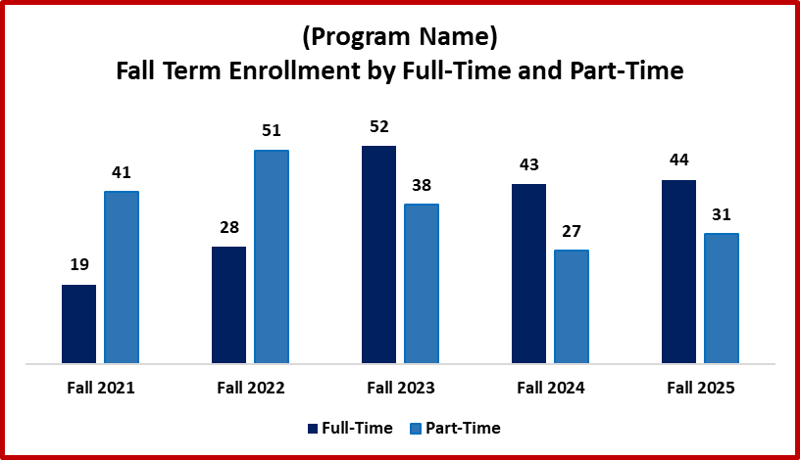
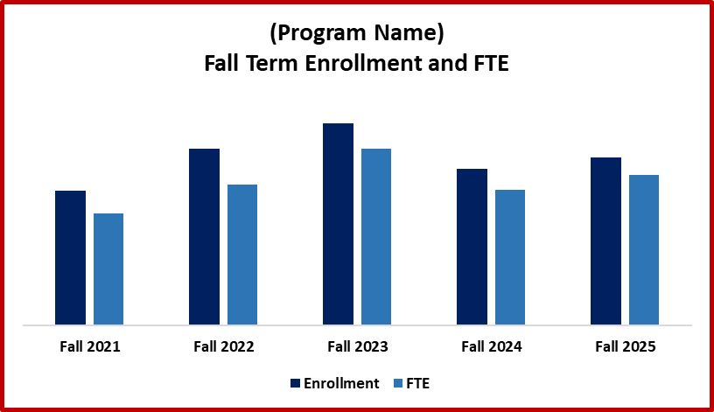



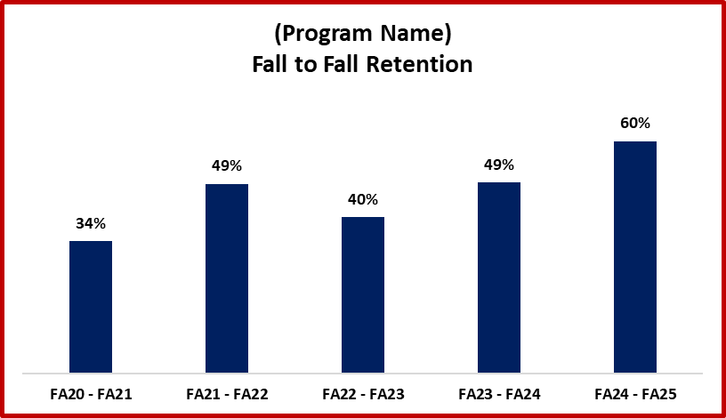
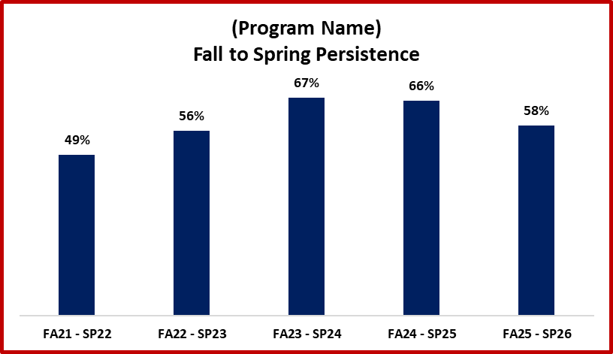

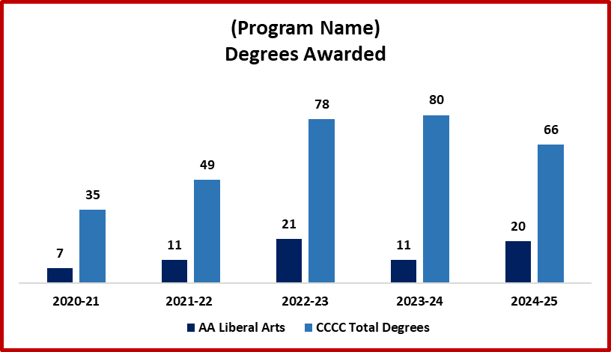
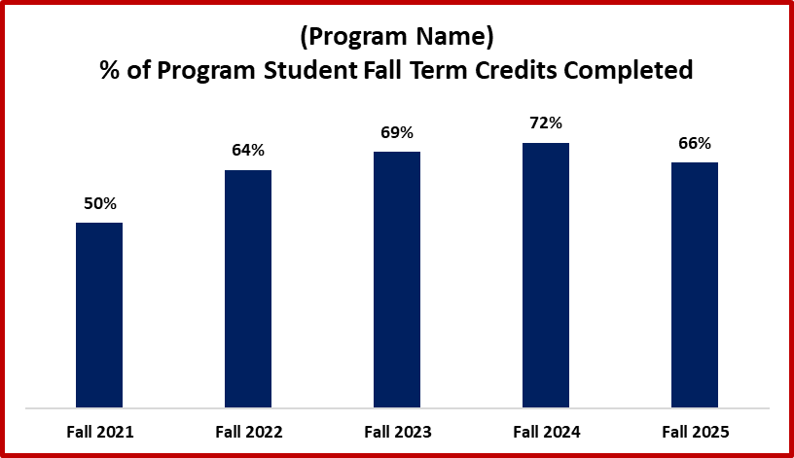

Program Highlights 2026-27

1. [type here]

2. [type here]

3. [type here]

Current Program Goals 2026-27
[as reported on the Fall 2026 Program Goal Status Report]

1. [prefilled]

2. [prefilled]

3. [prefilled]

Progress on Current Program Goals 2026-27
1. [type here]

2. [type here]

3. [type here]

Updated/Revised Program Goals for 2027-28
[Note: At least one program goal will be targeted at improving classroom pedagogy or curriculum.]

1. [type here]

2. [type here]

3. [type here]


Annual Program Goals
2026 – 2027 Academic Year

Program Faculty: Click or tap here to enter text.

Program Goals (as reported on Spring 2026 Program Snapshot):

- [Prefilled from spring snapshot]
Enter Status Goal 1, 8/2026: Click or tap here to enter text.

- [Prefilled from spring snapshot]
Enter Status Goal 2, 8/2026: Click or tap here to enter text.

- [Prefilled from spring snapshot]
Enter Status Goal 3, 8/2026: Click or tap here to enter text.

Update current goals with any changes below. If goal is unchanged, refill in the goal as is.

Current Updated/Revised Program Goals for 2026-2027
[Note: At least one program goal should be targeted at improving classroom pedagogy or curriculum.]

1. Click or tap here to enter text.

2. Click or tap here to enter text.

3. Click or tap here to enter text.

Program Goal Status Template

Program Review Exit Meeting
Program Review Exit Meeting Template

Program: Exit Meeting Date:

Curriculum Committee and Academic Dean Recommendations:
[Prefill from Program Review]

Faculty Recommendations:

Program Changes (if applicable):
[Prefill from Program Review]

Program Budgetary Needs (be specific):

Student Materials and Supplies
Need:
Budgetary means of fulfillment:

Staff Materials and Supplies
Need:
Budgetary means of fulfillment:

Promotional Materials/Advertising
Need:
Budgetary means of fulfillment:

Physical Plant Allocation/Change
Need:
Budgetary means of fulfillment:

Professional Development
Need:
Budgetary means of fulfillment:

Other Program Needs (describe in detail):
Need:
Budgetary means of fulfillment:

Attendee Signatures:

_______________________________ ________________________________
President Academic Dean

________________________________ ________________________________
Dean of Administration/IT Dean of Student Services

________________________________ ________________________________
Curriculum Chair Chief Financial Officer

________________________________ ________________________________
Program Faculty Human Resources

________________________________ ________________________________
Program Review Administrator Other/Title

________________________________ ________________________________
Other/Title Other/Title

